BIT 4107 – Mobile Application Development
ENHANCED PROFESSIONAL STUDENT LOGBOOK
Student Name: ABUNA RICHARD.
Admission Number: BIT/2024/73577.
School/Faculty: SCHOOL OF COMPUTING & INFORMATICS.
Programme: INFORMATION TECHNOLOGY.
Academic Year: 3.
Semester: 2.
Lecturer: MR. MICHAEL NYORO.
Phone Number: 0725865117.

Instructions
This logbook is used to document weekly learning activities, practical exercises, skills acquired, challenges encountered, solutions applied, and reflections. Students should complete all sections every week.
Each week to follow remarks in week 1 section.

Autogenerated Table of content

Week 1: Introduction to Mobile Application Development

Practical Activities Undertaken
only screenshots needed and labeling
Screenshots/Evidence Attached (Yes/No)

Tools/Software Used
SOFTWARE USED.
- Android Studio
- Kotlin programming language
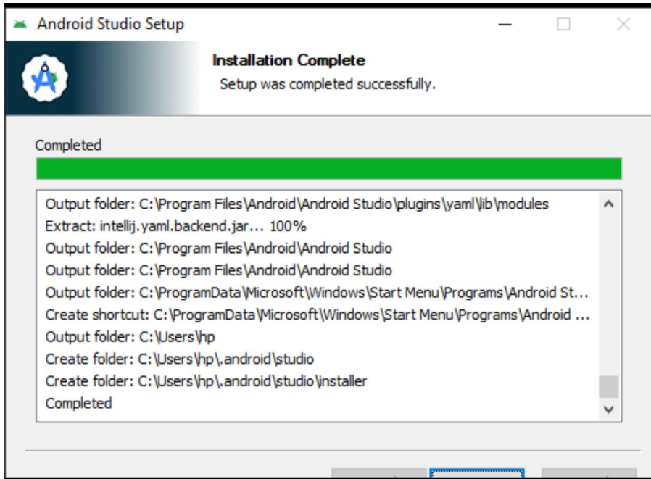
android studio installation.
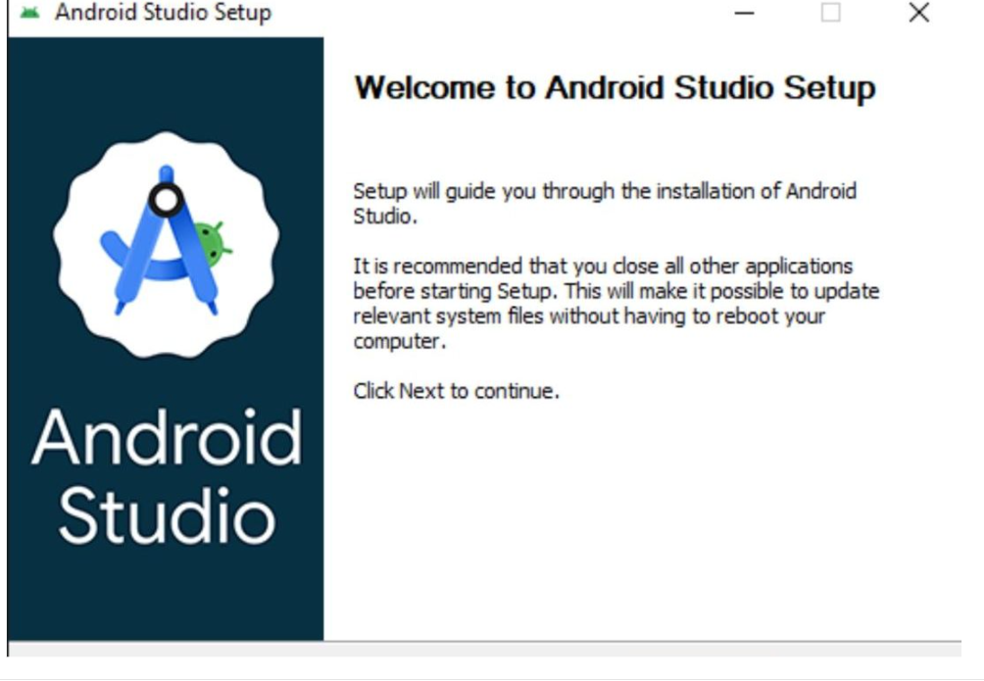
Android studio fully setup.

Personal Reflection
I have learned on how to set up the environment and complete installation for the android studio though it was so challenging a little bit.

Week 2: Mobile Development Environment
Same as week 1
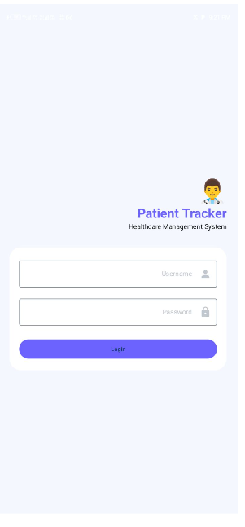
A simple login page.
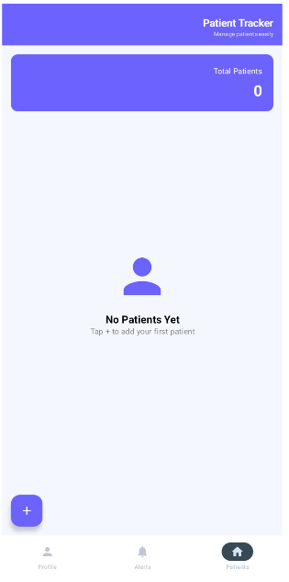
The dashboard screen.

Personal Reflection
I was able to build a simple login page and the dashboard as well which was a great achievement.

Week 3: User Interface Design
Figma design.
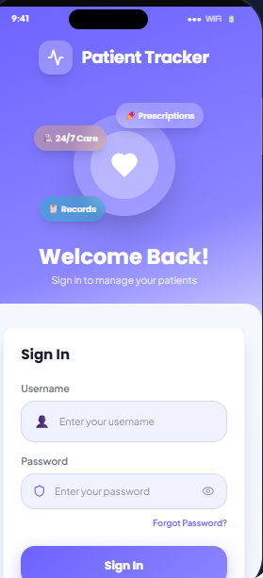

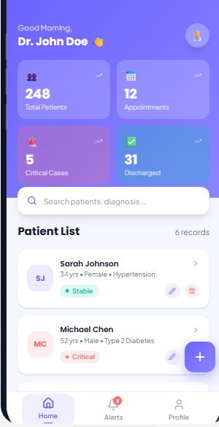
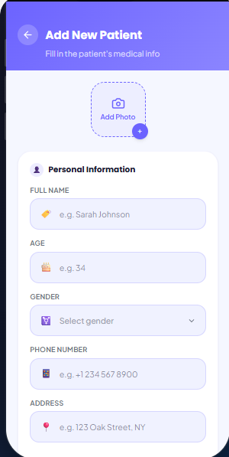

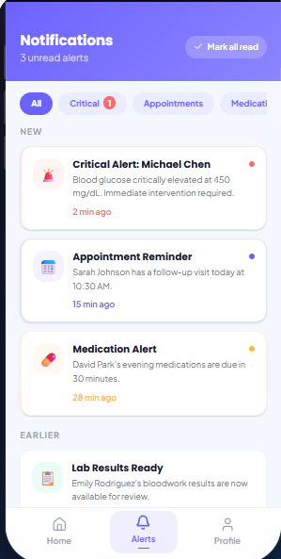

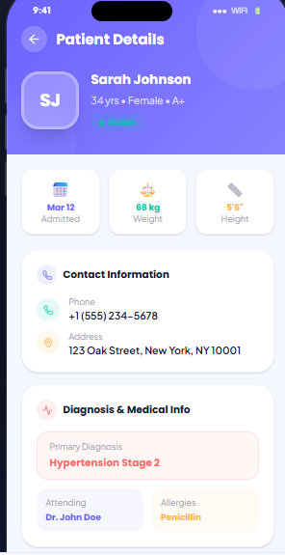

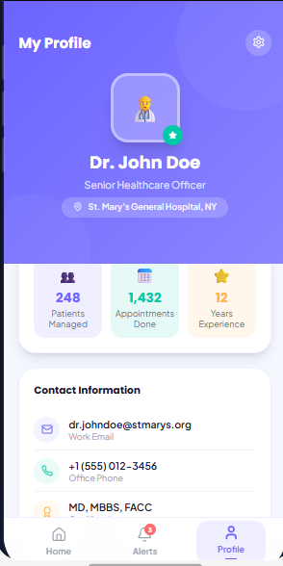

Personal Reflection
At this stage I was able to do the design using the Figma which is attractive and interactive as well which was an a skilled that I did earned personally.

Week 4: Event Handling and User Interaction
The patient tracker has a user interaction that allow to click the button events handling which are responsive.
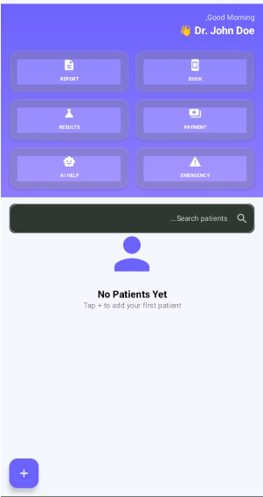
The plus button is responsive when click the admin is able to add the patients in the system.
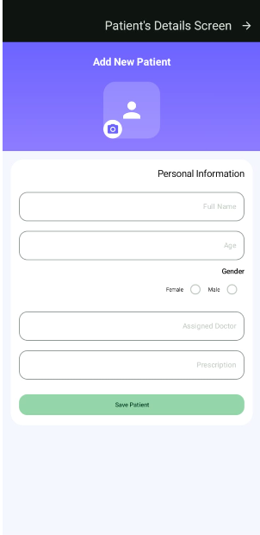
After the plus button is clicked this is what it shows the output of the button. And the save patient button save the changes done for the patient by the admin.

Week 5: Data Management
This is the data management I have linked firebase database with my patient tracker project.
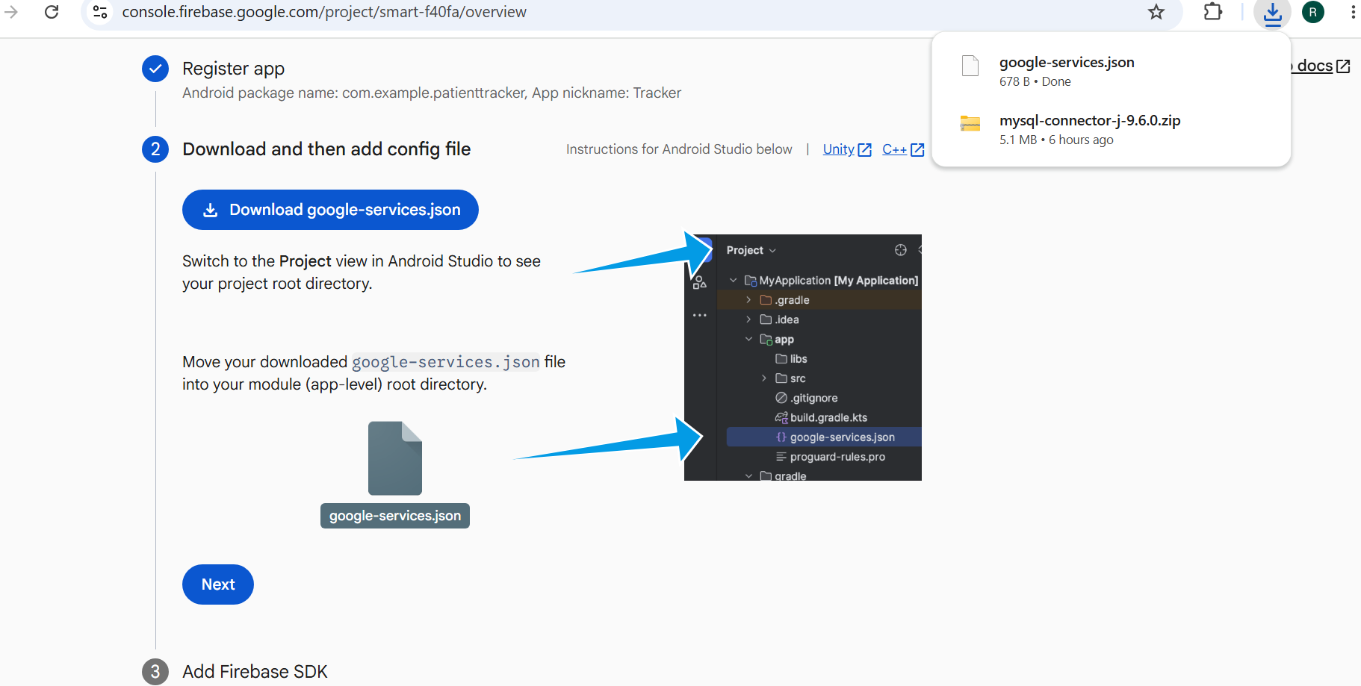
Linking of my project with the firebase database.

Week 6: Networking and APIs

Same as week 1

Week 7: Application Architecture

Same as week 1

Week 8: Project Planning

Week 9: Device Features and Sensors

Same as week 1

Week 10: Notifications and Background Services

Same as week 1

Week 11: Mobile Security

Same as week 1

Week 12: Testing and Debugging

Same as week 1

Week 13: Application Deployment

Same as week 1

Week 14: Final Project Presentation

Same as week 1

Semester Project Tracking

Project Title

Project Objectives

Project Requirements

Development Milestones

Testing Results

Lessons Learned

Future Improvements

End of Semester Reflection

Summary of Skills Acquired

Most Interesting Topic

Major Challenges Faced

How Challenges Were Overcome

Professional Growth Achieved

Overall Course Experience

Final Approval
Student Name: __________________________
Student Signature: ______________________
Date: _________________________________
Lecturer Name: _________________________
Lecturer Remarks: _____________________
Date: _________________________________

